How do I register as a New User?
Click New User Register Here.
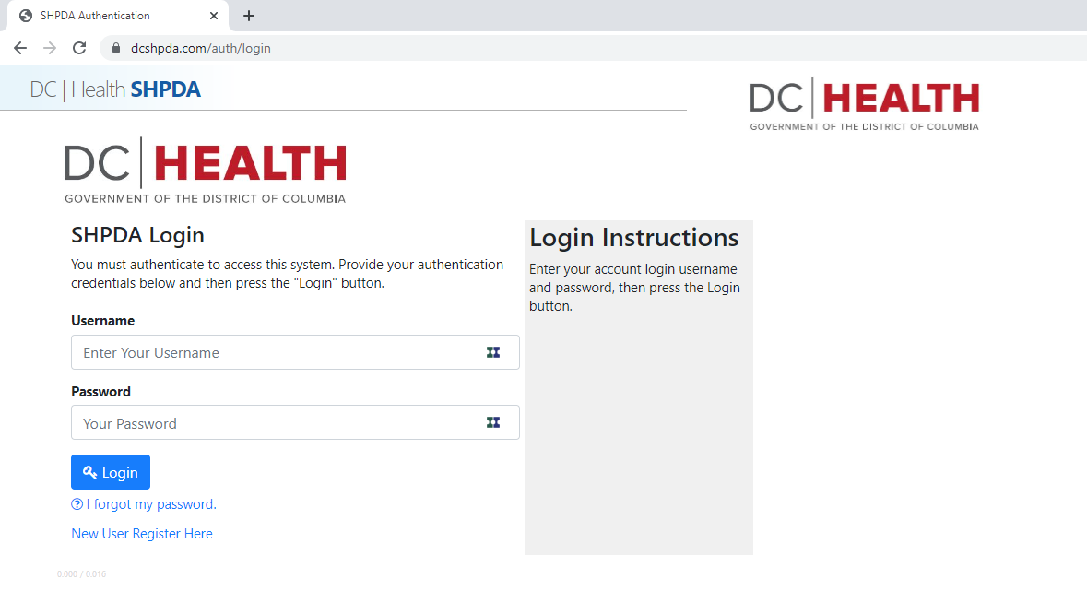

How do I create a Health Provider or Facility Profile?
Create your User Account and check the box to Add New Health Provider Profile.
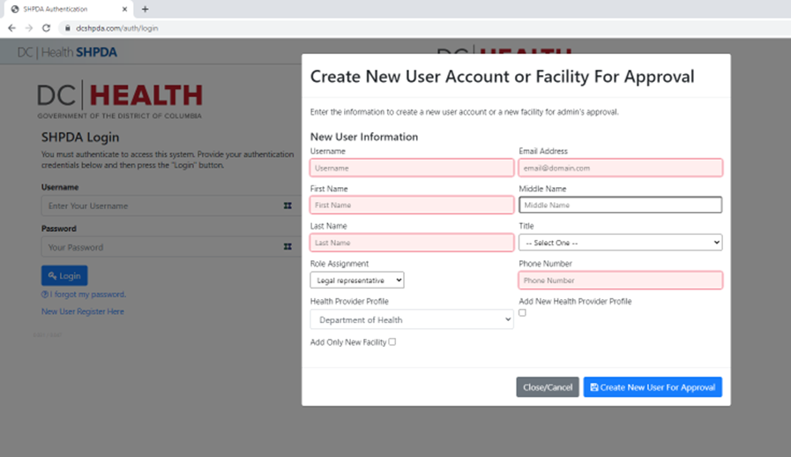

I have a User Profile. How do I add a new Health Provider or Facility Profile?
Check the box to Add Only New Facility.
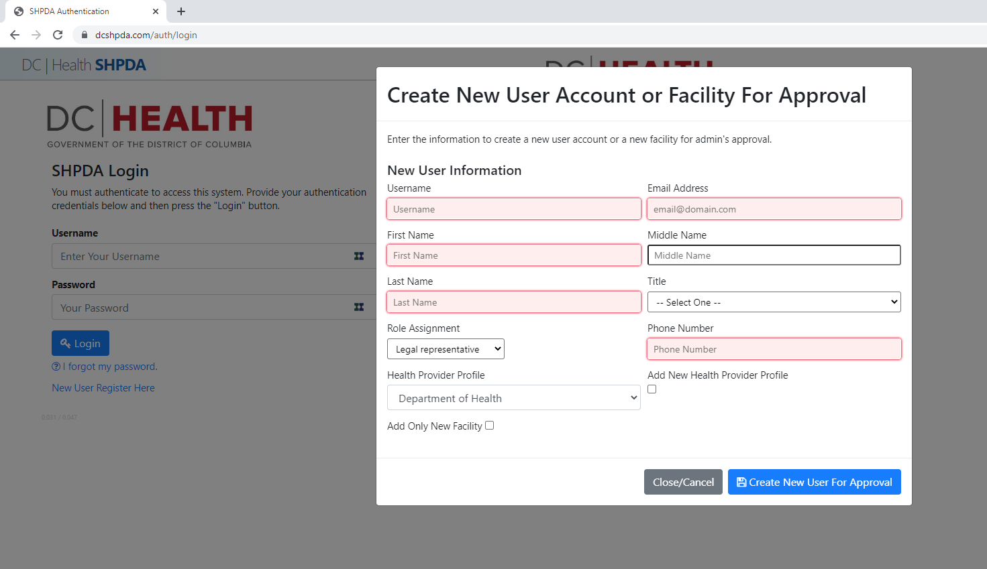

Do I have to submit a Letter of Determination before submitting a Letter of Intent?
No, if you believe a Certificate of Need is required to offer or develop a health service or facility or to obligate a capital expenditure in the District of Columbia, you may submit a Letter of Intent without obtaining a determination from the SHPDA.

Do I have to submit a Letter of Intent before submitting an Application?
Yes, with very limited exceptions, a Letter of Intent is required to initiate to Certificate of Need application process.

I submitted a Letter of Intent. When can I submit my Certificate of Need Application?
Once your Letter of Intent is accepted by the SHPDA, you may begin completing a Certificate of Need Application. With limited exceptions, the Application will not be accepted by the SHPDA until the sixty (60) day waiting period expires.

Where can I find my saved Application?
Click CON Applications from the dropdown.
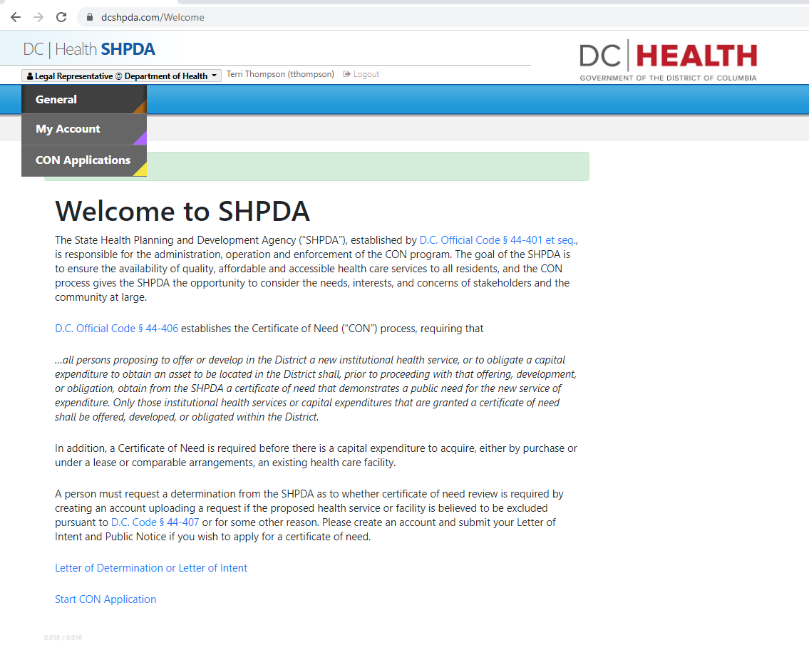
Click Application Queue then Select a Queue.
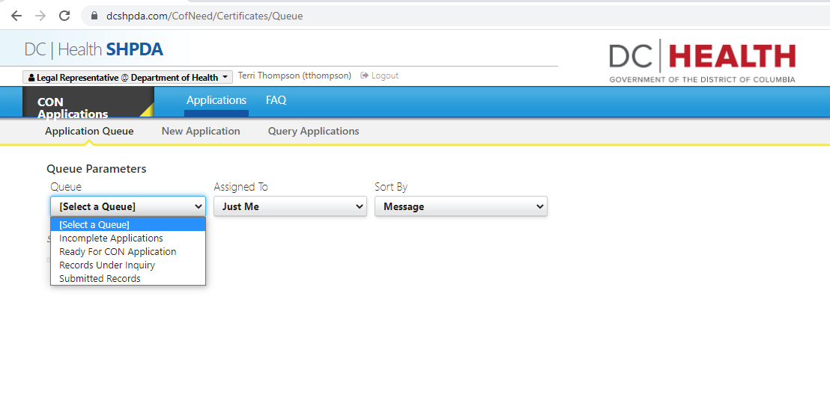

There is more than one person assigned to my facility. How do I find their saved Application?
Click My Health Provider Profile. The Records associated with the Health Provider Profiles to which you are assigned will be listed.
